 |  | Amy Harbourne
About Me  I am a senior at Texas A&M University, majoring in English, and pursuing further academic experiences to help me grow. I have a history of reliability and enthusiasm for my work. I am an avid reader, studious, punctual, and have a drive for excellence. I intend to pursue Rhetorical Analysis for my post bachelor education and hope to have a career in Academia.  Contact  PHONE: 956-466-5507  EMAIL: aharbourne@ymail.com  Secondary email: amyharbourne@gmail.com  Awards and Accolades  Hilton College Station Conference Center: I was honored with Employee of the month as well as nominated for the national CEO of Light and Warmth Award. (Winner announcement postponed due to COVID-19)  Texas A&M University: I obtained a certificate in professional writing, awarded in recognition of training in a broad range of writing skills  Languages  English: Advanced proficiency  Spanish: Intermediate proficiency  German: Intermediate proficiency  - President of A&M German Club from 2019-2020  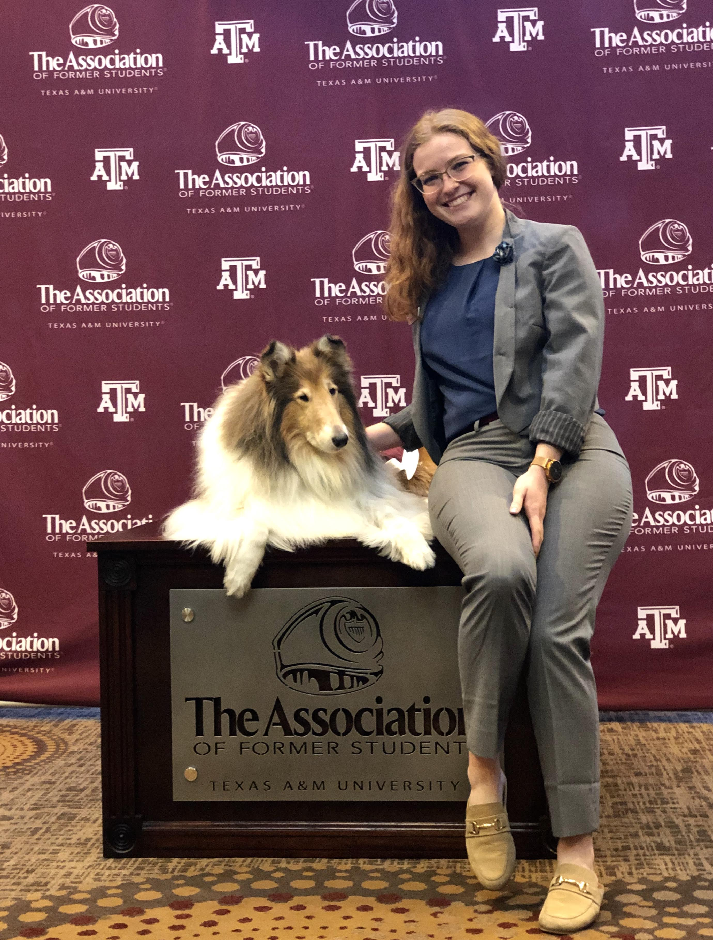 |  | EDUCATION  New York University  Fall 2016  Blinn College  Spring 2017 – Spring 2018  Texas A&M University  Spring 2018 – Fall 2020  BA in English  WORK EXPERIENCE: Contact information upon request  Chick-Fil-A, College Station, TX: Team Member  March 2017 – October 2017  Duties: Performing the “Core Four”: Eye contact, Smiling, Speaking Enthusiastically, and Staying Connected with every guest.  Tribune Festival, Austin, TX: Social Media Ambassador  Fall 2017  Reported information shared by politicians and speakers on issues in Texas while networking with politicians and speakers.  Hilton Conference Center, College Station, TX: Front Desk Agent and Chair of Sustainability for Blue Energy Committee  October 2017 – March 2020 (COVID layoff)  At the front desk, I am responsible for not only checking in guests, but paying attention to details important for a successful stay: contact and payment information, events being hosted in our conference center, and connecting with guests to make sure everything goes smoothly.  Medical Internships and Experiences: Observer  Over the years, I have had the privilege to observe various medical procedures. The list includes multiple heart surgeries at the Woodlands Heights Hospital and podiatric surgeries at the Valley Baptist Medical Center Brownsville. In the Spring of 2012, I Shadowed Dr. Flores and Dr. Nieves in the OB/GYN of Valley Regional Hospital and observed patient visits, various surgeries and procedures (hysterectomy, c-sections, cone biopsy etc.) and was required to keep a record of all observations.  Wikipedia Student Editor  Spring 2020 – Present  As a wiki-editor, my focus is primarily on issues of organization, appropriateness, and Wikipedia style, with the aim of significantly improving the existing content of an article. I have worked within the Wikipedia infrastructure, including engaging with current interested editors and leaving traces of my work to assist with future editing of the articles I worked on  Projects and Publications:  Sclera color in humans facilitates gaze perception at night — co-author and editor  Spring 2018-Spring 2019  This research studied gaze detection concerning the importance and function of the sclera in human communication and ability to determine the direction of gaze.  What do you Meme: a Look at Historical and Literary Imitative Humor Bachelor's Thesis  Spring 2020  A nuanced research of historical texts and the authors who wrote them through the lens of contemporary theories and perspectives that draw parallels from the Ancient Greeks and Shakespeare to today’s imitative internet culture. As well as being published in the OAK Trust depository, this manuscript has also been published in the TAMU Explorations Journal.  Comprehensive City Plan for Bryan, Texas — Project manager  Spring 2018  Managed Aesthetics and Vitality planning and Researcher for Policy and Public Opinion  Public Contact Information  Dr. Sara Dicaglio  979-847-8550  sdicaglio@tamu.edu  Dr. Andrew Pilsch  979-862-3556  apilsch@tamu.edu  Dr. David Brenner  (979) 845-2124  dab23@tamu.edu

